Nosecone and Trajectory Analysis

MAE 157A: Fluid Mechanics and Aerodynamics Laboratory

**Prescott Rynewicz, UCLA MAE Undergraduate Student**

Professor

R. Mitchell Spearrin, Ph.D.



Table of Contents

**Introduction** 4

**List of Tables** 5

List of Figures 6

**Individual Tasks** 7

Results 7

Nosecone Fluent Analysis 7

Discussion 12

Team Tasks 14

Wind Tunnel Testing 15

Fiberglass Nosecone Molding 20

Trajectory Analysis 22

Amazon C6-3 23

Big Bertha B6-4 26

Bull Pug B6-4 29

Trajectory Discussion 32

Plot Discussion 32

Affect Of Mass 32

Effect of Launch Angle 32

Malfunctioning Altimeter 32

**Summary and Conclusions** 34

**Statements of Participation** 35

Individual Tasks 35

Team Tasks 35

Team Members Rated 35

**Appendices** 36

Matlab Code 36

Sample Wind Tunnel Data 38

Images 39

## Trajectory Analysis

The trajectory analysis includes simulations for three different model rockets that were previously launched and collected trajectory data during flight. The code used for the analysis is the code developed by the SpaceY team for the Preliminary design review of the MAE 157A class. Below, plots for three cases of simulations are presented, along with the plots for the experimentally collected data. The three cases include

1. Trajectory analysis with no drag
2. Trajectory analysis with Cd_coast = 0.5 and Cd_recovery = 1.5
3. Trajectory analysis with Cd_coast = 0.8 and Cd_recovery = 2.0

The model rockets used in the analysis include

1. Amazon C6-3
2. Big Bertha B6-4
3. Bull Pug B6-4

## Amazon C6-3

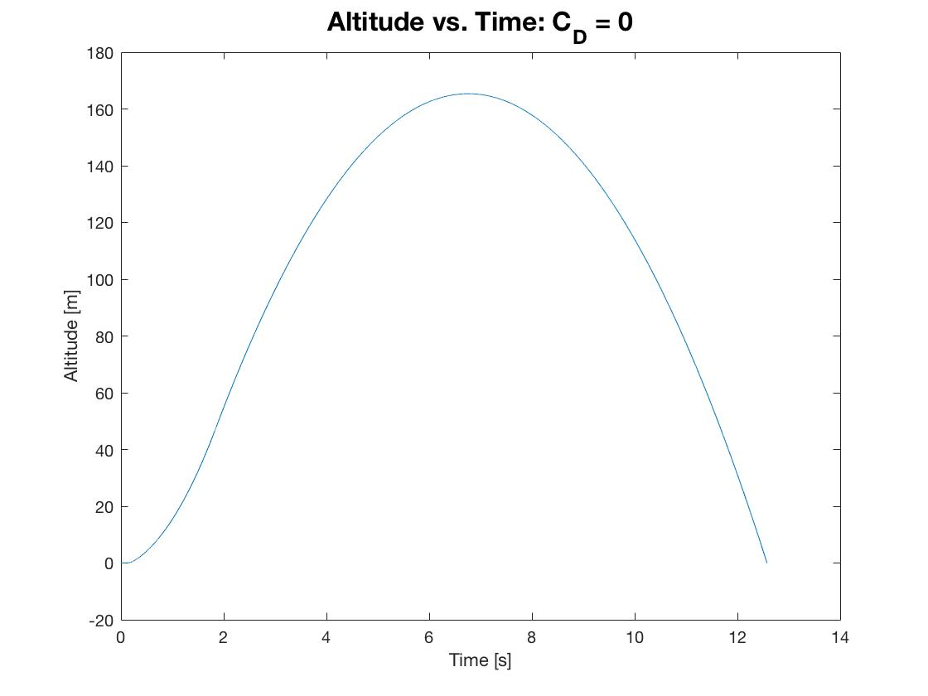

Figure 18: Amazon C6-3 Trajectory Analysis with No Drag

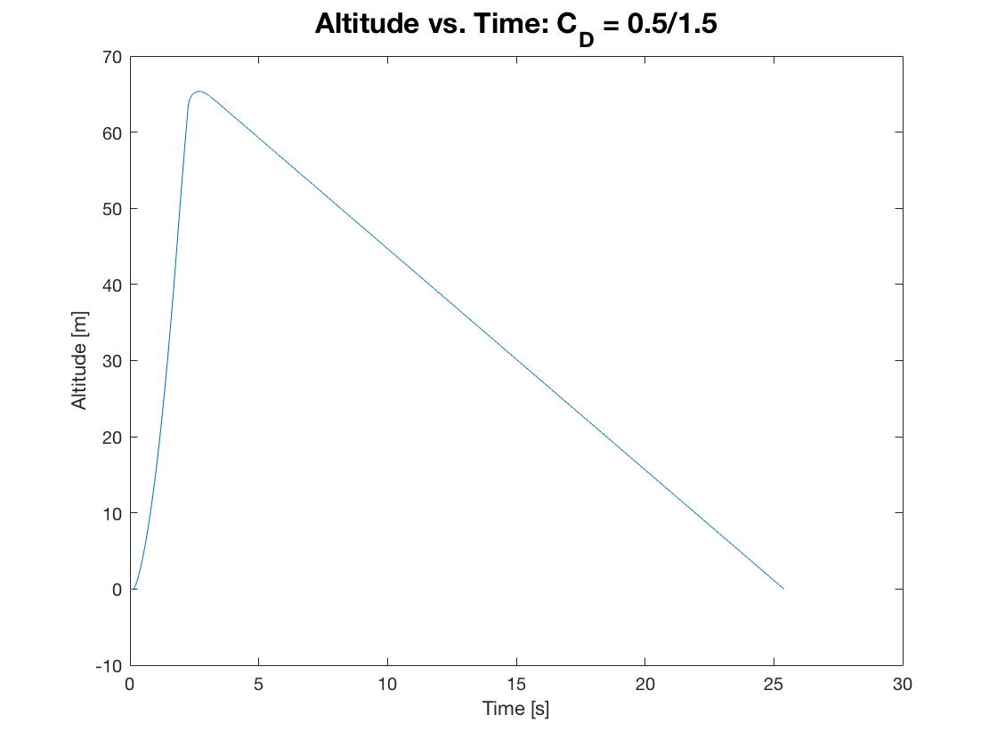

Figure 19: Amazon C6-3 Trajectory Analysis with Drag Condition 1.

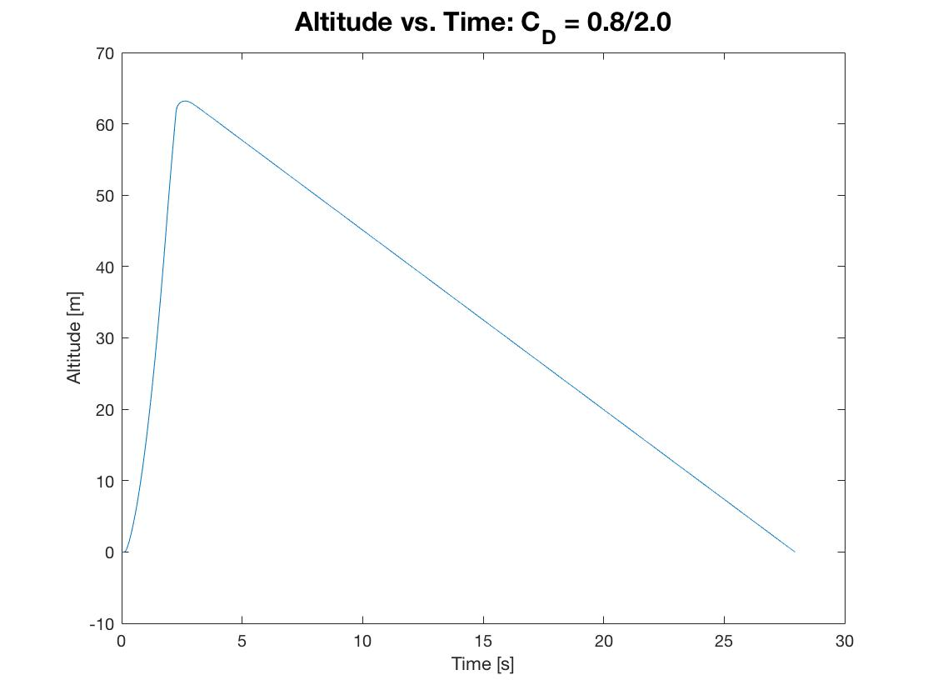

Figure 20: Amazon C6-3 Trajectory Analysis with Drag Condition 2.

|  |  |  |  |
| --- | --- | --- | --- |
| Drag | Apogee Height [m] | Burnout Time [s] | Descent Velocity [m\s] |
| None | 164.4 | 1.86 | N/A |
| CD = 0.5/1.5 | 65.0 | 1.86 | -2.90 |
| CD = 0.8/2.0 | 63.1 | 1.86 | -2.51 |

Table 5: Amazon C6-3 Numerical Results for Three Different Simulations.

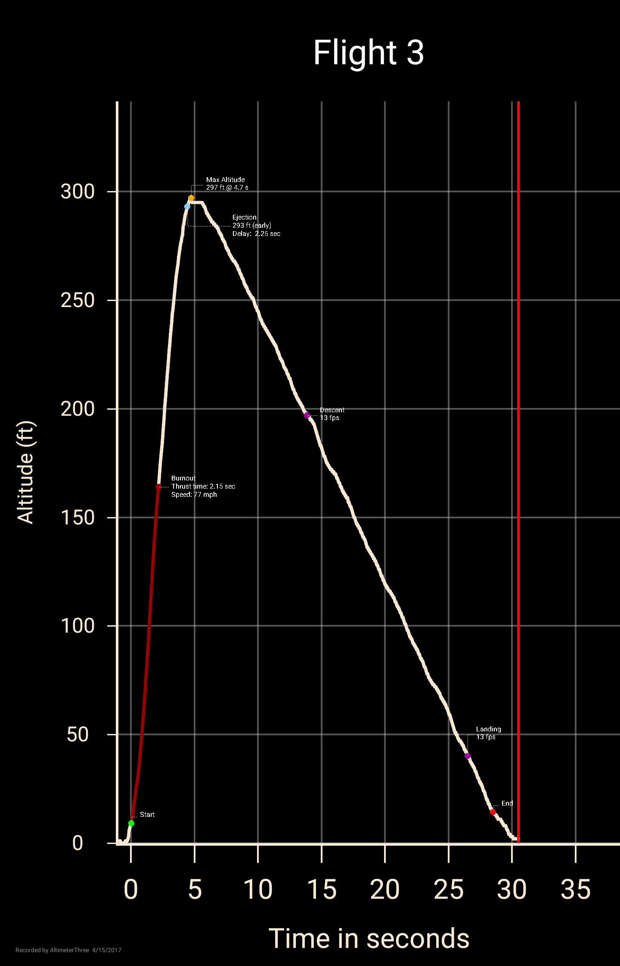

Figure 21: Experimentally collected altimeter data for the Amazon C6-3.

## Big Bertha B6-4

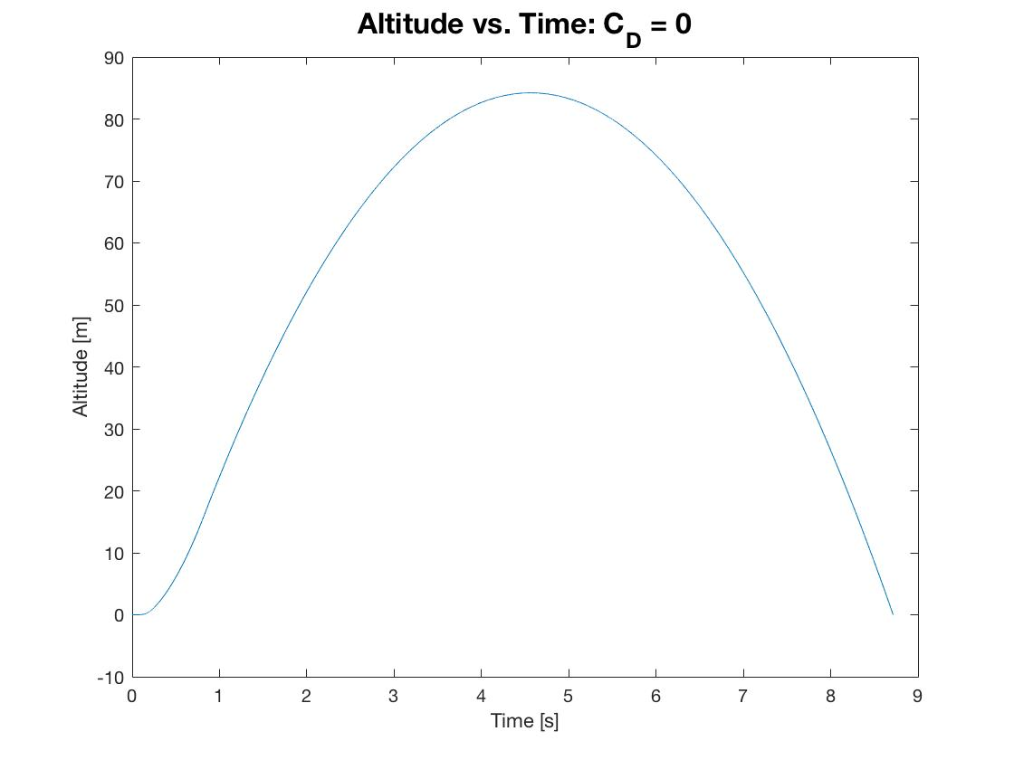

Figure 22: Big Bertha B6-4 Trajectory Analysis with No Drag

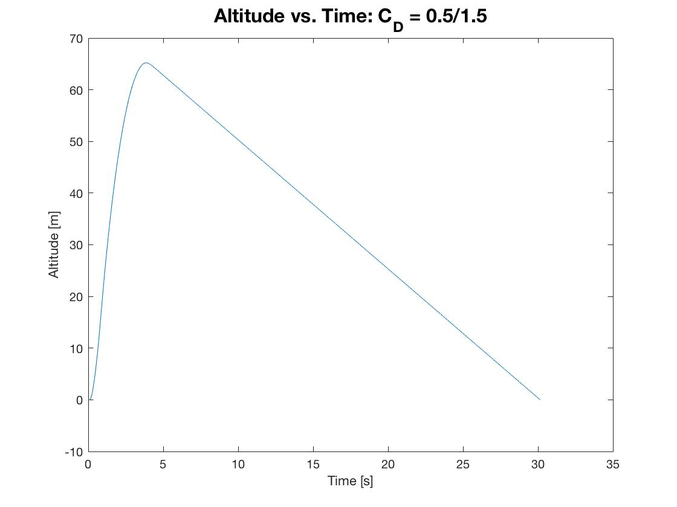

Figure 23: Big Bertha B6-4 Trajectory Analysis with CD = 0.5/1.5

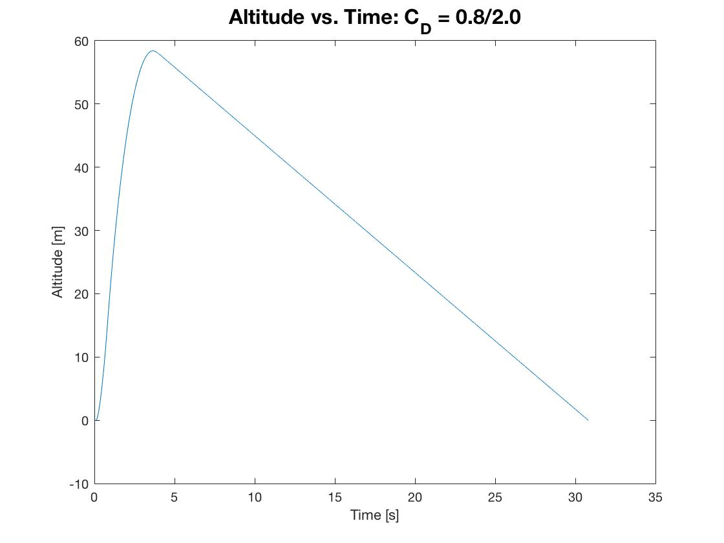

Figure 24: Big Bertha B6-4 Trajectory Analysis with CD = 0.8/2.0

|  |  |  |  |
| --- | --- | --- | --- |
| Drag | Apogee Height [m] | Burnout Time [s] | Descent Velocity [m\s] |
| None | 84.6 | 0.86 | N/A |
| CD = 0.5/1.5 | 65.5 | 0.86 | -2.49 |
| CD = 0.8/2.0 | 58.8 | 0.86 | -2.16 |

Table 6: Big Bertha B6-4 Numerical Results for Three Different Simulations.

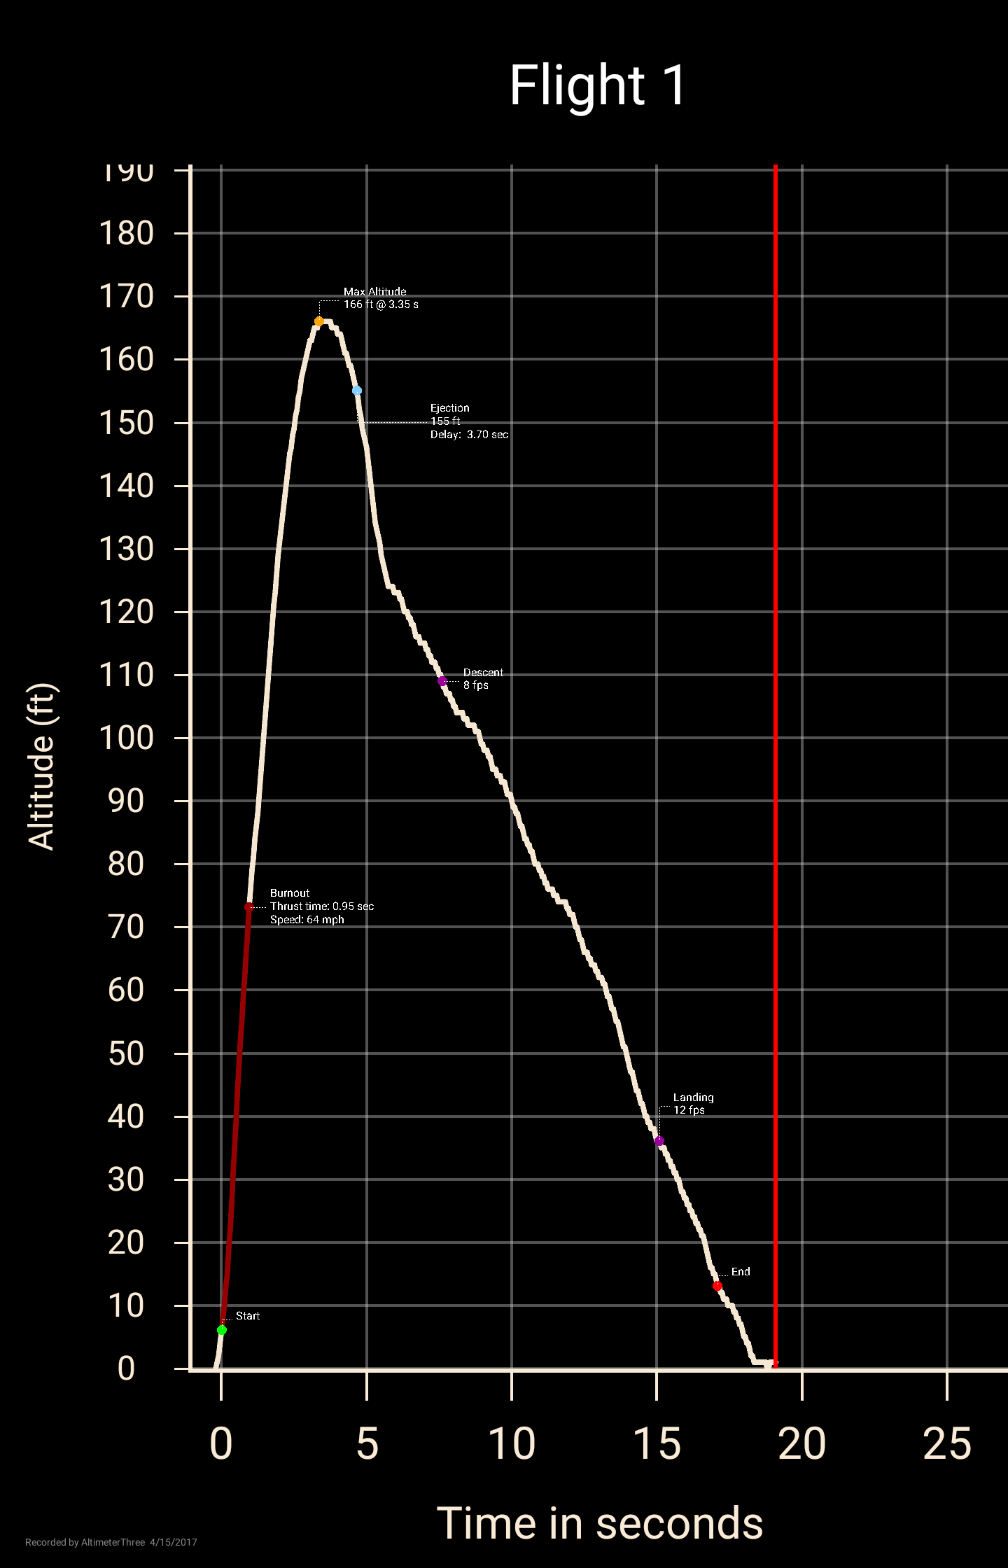

Figure 25: Experimentally collected altimeter data for the Big Bertha B6-4.

## Bull Pug B6-4

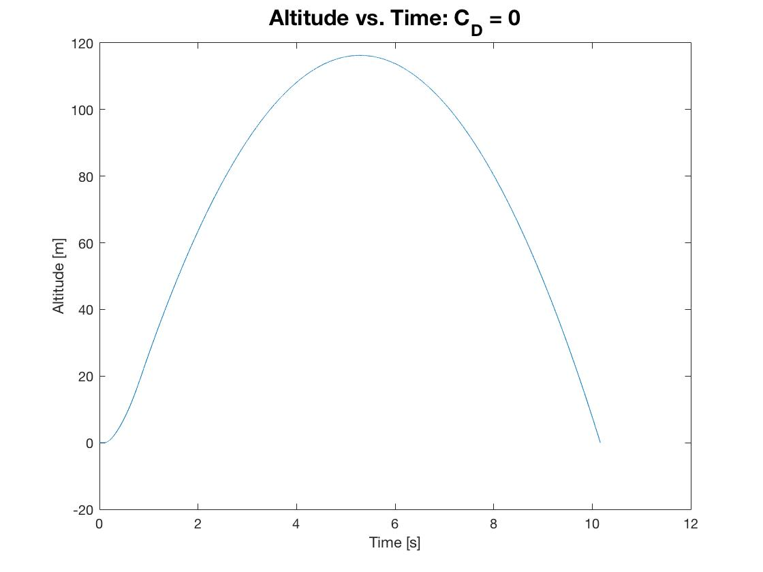

Figure 26: Bull Pug Trajectory Analysis with No Drag

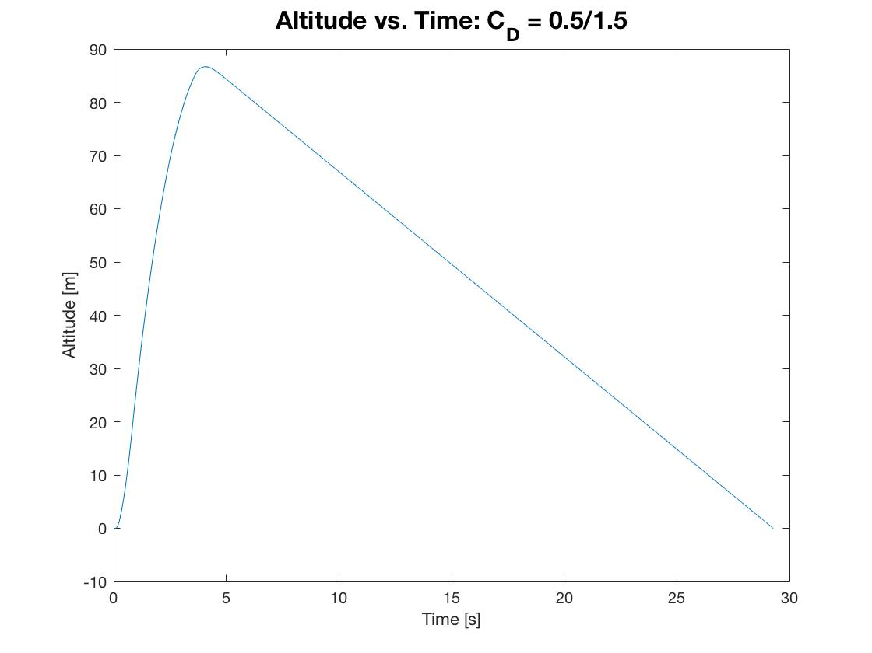

Figure 27: Bull Pug Trajectory Analysis with CD = 0.5/1.5

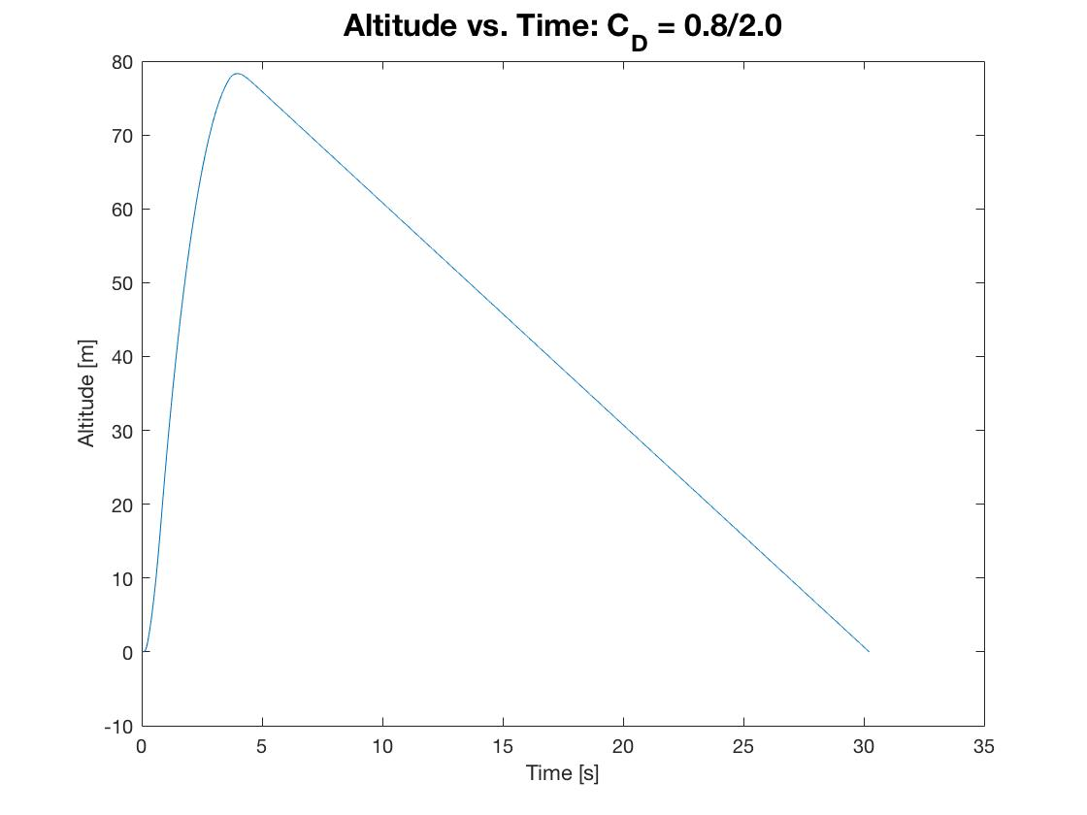

Figure 28: Bull Pug Trajectory Analysis with CD = 0.8/2.0

|  |  |  |  |
| --- | --- | --- | --- |
| Drag | Apogee Height [m] | Burnout Time [s] | Descent Velocity [m\s] |
| None | 117.4 | 0.86 | N/A |
| CD = 0.5/1.5 | 87.2 | 0.86 | -3.47 |
| CD = 0.8/2.0 | 78.3 | 0.86 | -3.00 |

Table 7: Bull Pug B6-4 Numerical Results for Three Different Simulations.

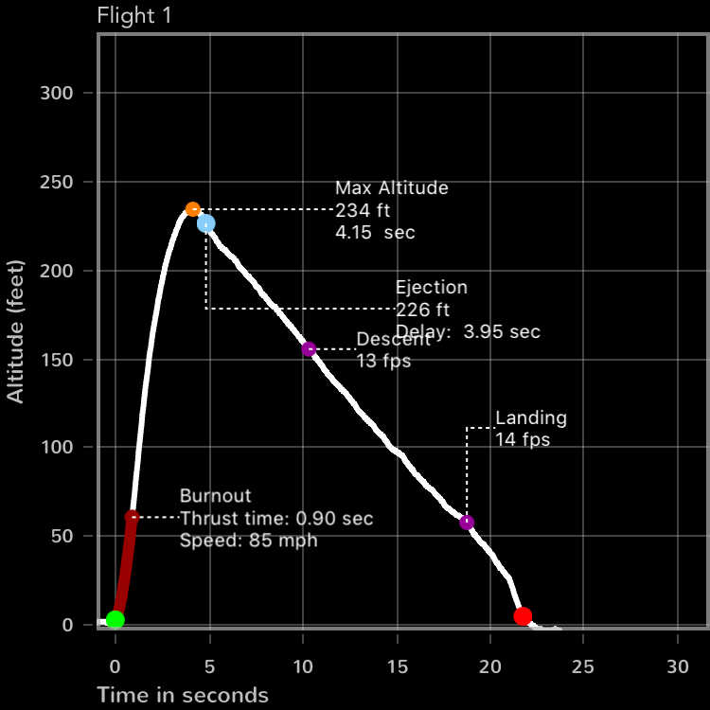

Figure 29: Experimentally collected altimeter data for the Bull Pug B6-4.

## Trajectory Discussion

### Plot Discussion

The results from the simulations for the three different vehicles show uniform plots. The trends with the same input drag conditions, end up creating consistent trends. The biggest factor of uncertainty are the differences between the available data online for the rocket motors and the experimental results, as it has been shown that the rocket motors to show significance deviance between motors. For the no drag plot, we see a complete parabolic position plot, as terminal velocity is never achieved, and the vehicle is always accelerating. As the drag is increased, the apogee height of the flight time increases. Generally, between the second and third simulation cases, we see a small increase in total flight time, but that total flight time is also highly dependent on the altitude achieved at apogee and the final weight of the vehicle after burn.

### Affect Of Mass

By increasing the mass of the vehicle, the burnout velocity will decrease and the altitude during coast will also decrease. Due to higher mass, there will be a greater gravitational force on the rocket as it ascends, thus will accelerate at a lower rate, achieve a lower velocity, and thus a lower overall altitude.

### Effect of Launch Angle

When running simulations with the Estes Bull Pup model rocket, at both launch angles of zero and ten degrees, the difference between apogees is quite small. The percent difference between the two is 0.53%. This small difference is due primarily to the fact that 10 degrees is still a very small angle, and in most cases can be assumed part of the small angle assumption, meaning that cos(10) = 1 and sin(10) = 0, thus causing a small effect on the trajectory performance of the simulations.

### Malfunctioning Altimeter

If your altimeter does not function properly during flight then a method to obtain an estimate of the flight apogee would be to assume that when the parachute deploys you have roughly reached apogee. Then, collect the time between parachute deployment and touchdown. With this, it is possible to obtain the apogee height using the known or experimentally calculated descent velocity of the vehicle and the descent time. Assuming constant descent velocity for a majority of descent, due to the high drag and terminal velocity for the recovery configuration of the vehicle, the apogee would be the descent velocity time the descent time.